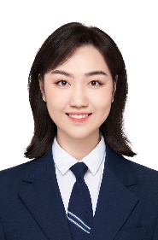
Zhuoting Li (Christine)
Jintong Road No.2000, Tangjiawan Town, Zhuhai, Guangdong Province
Tel: +86-15881848200 s230006102@mail.uic.edu.cn
Education
Beijing Normal University-Hong Kong Baptist University United International College (Sep. 2022-Jun. 2026)
Bachelor of Business Administration (Honors) (Accounting)
Cumulative GPA: 3.62/4.00

Research Experience
Research Assistant (Sept. 2023-now)
I am research assistant to Sebastian Boo, Department of Management, Birkbeck College, University of London
- I undertook a range of research tasks including: using electronic databases to identify specific research paper and data; using the Zotero reference management software; extracting and summarising information from journal articles.
Work Experience on Campus
Minister, Art&Show Drama Association (Mar. 2023- now)
- Organized large-scale events such as the Campus Cultural and Dramatic Festival.
- Participated in sketch shows, and won the Excellence Award of Zhuhai City Sketch Competition in 2023.
- Booked venues and organized personnel.

Skills and Qualifications
Strong English: Using English as official instruction language in the university, passed CET-4
Native speaker of mandarin
Proficient office software skills: Word/PowerPoint/Excel
Experienced Presentation skills and teamwork spirits: Every course requires English group presentations
Learning ability: Second class scholarship for year 2022-2023

